Project Development Phase
Performance Test
Date | 08 October 2026
Team ID | 9100Orbit
Project Name | Implement Client Script & UI Policy (Incident)
Maximum Marks
Model Performance Testing:
Project team shall fill the following information in model performance testing template.
S.No. | Parameter | Screenshot / Values
1. | Data Rendered | Incident records (Number, Caller, Impact, Urgency, Priority, Assignment group, Assigned to, State) shown on the Incident form and Incident list view.  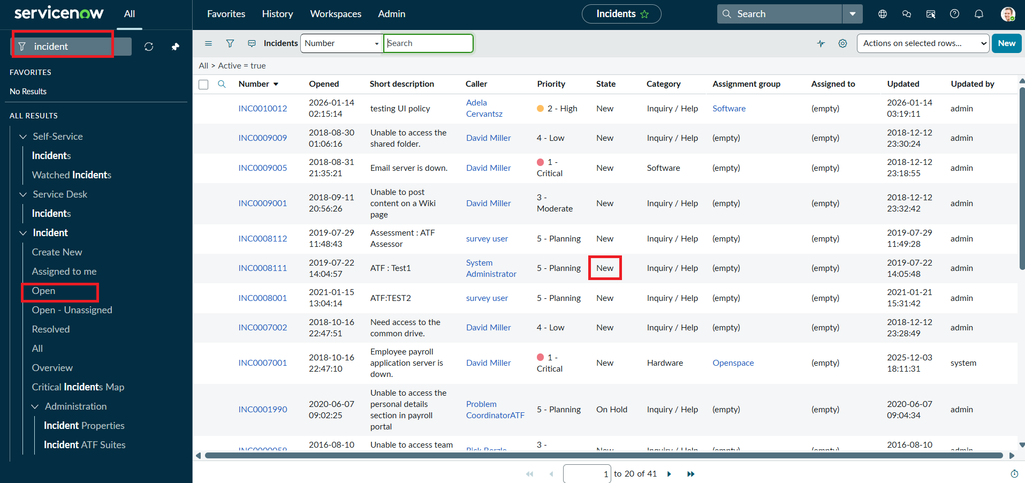
2. | Data Preprocessing | Data is validated at entry instead of preprocessed: Urgency is auto-set to High when Impact = High, and Assigned to is checked before save.  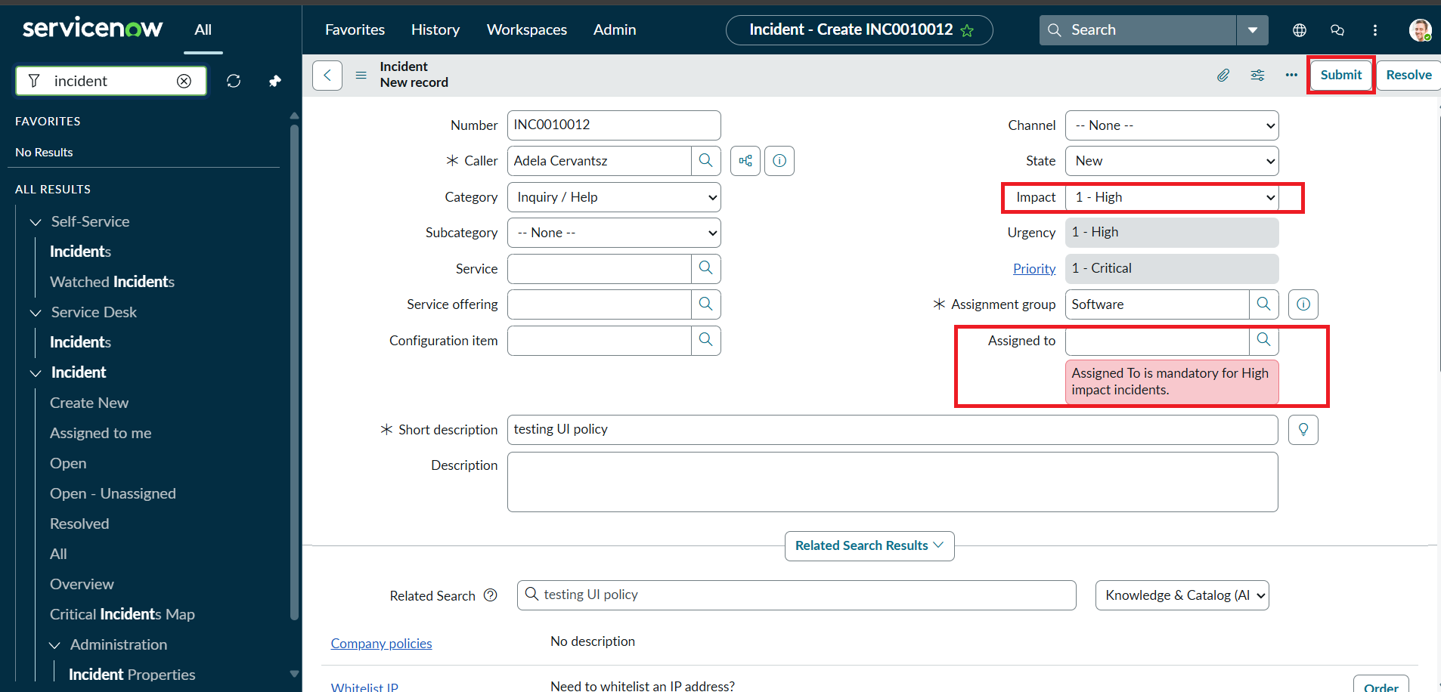
3. | Utilization of Filters | UI Policy condition: Impact is 1 - High. Incident list filter: Active = true. "Reverse if false" is enabled so changes revert when the condition is not met.  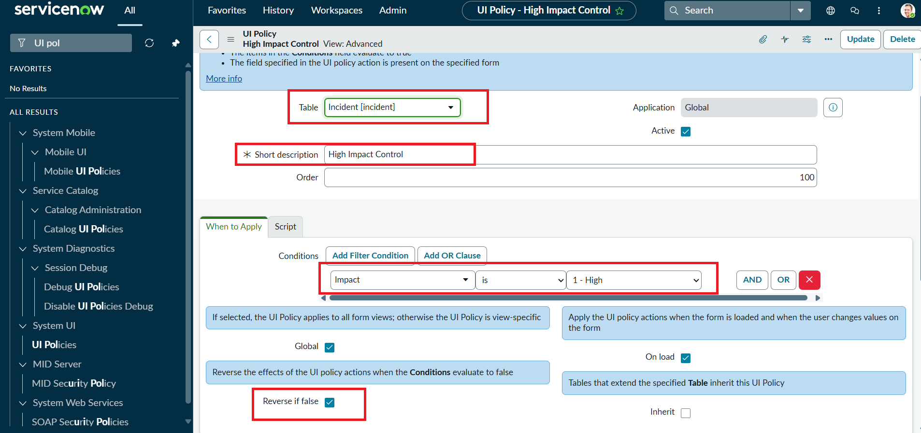
4. | Calculation fields Used | Not applicable - no calculation fields. Client Scripts (JavaScript) used: onChange, onSubmit, onCellEdit.  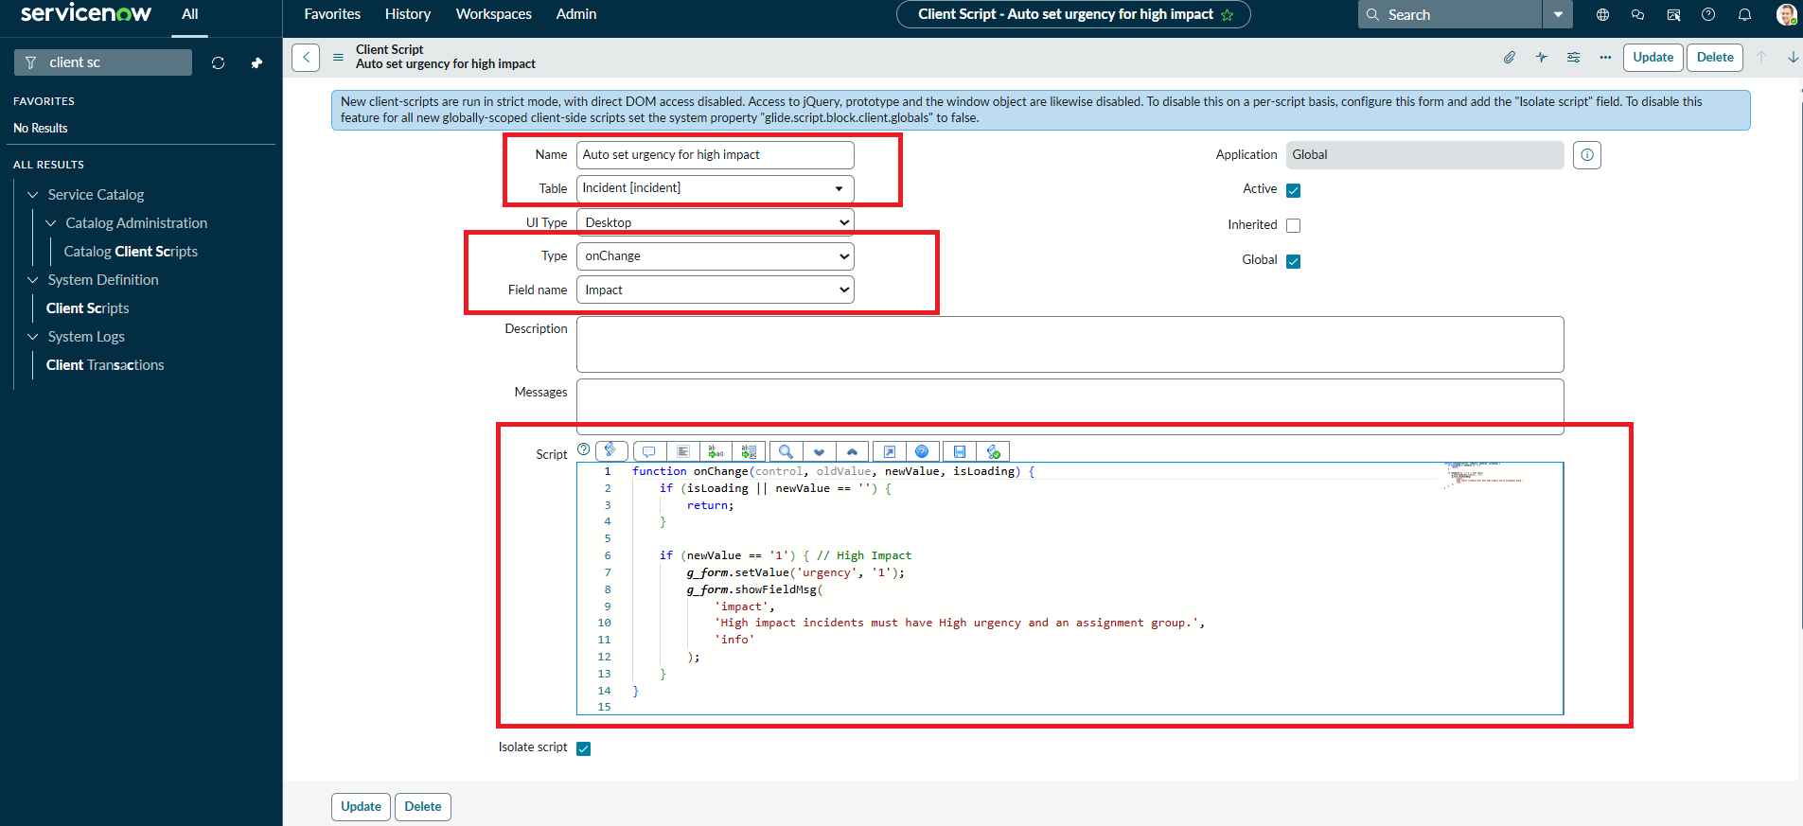
5. | Dashboard design | No of Visualizations / Graphs - 0 (not applicable; no dashboard in this project)
6 | Story Design | No of Visualizations / Graphs - 0 (not applicable; no story in this project)

